Theme 1 Population Name of the Student _________________________________

Demographic Transition Model (DTM)
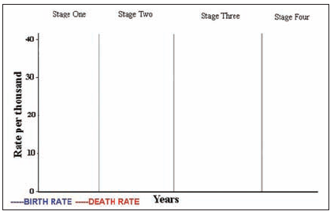

 | Stage One | Stage Two | Stage Three | Stage Four
Birth Rate

Death Rate

What’s going on? Why?

Condition of the total Population
(Natural Increase)

Examples

Population Pyramids

Analyze the structure and demographic characteristics in bullet points
